***JAYPEE INSTITUTE OF INFORMATION***

***TECHNOLOGY, NOIDA , SECTOR-62***

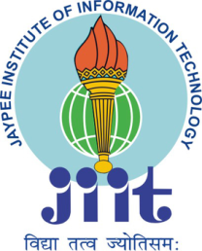

***LIFE SKILL***

***PROJECT BASED LEARNING***

***SOCIAL ISSUES : WOMEN EMPOWERMENT***

***SUBMITTED TO:***

***Dr. Ankita Das***

***BY :***

***TEAM MEMBERS (B10 BATCH):***

* ***HIMANSHU DIXIT (21103262)***
* ***AASHUTOSH PRADHAN (21103242)***
* ***ARYAMAN VISHNOI (21103260)***
* ***ARYAN RAZDAN (21103271)***

***(BTECH – CSE 2nd  SEMESTER)***

***acknowledgement***

*We extend our sincere thanks to* ***Jaypee Institute of Information and Technology*** *which provided us the opportunity to make the project using lifeskill concept which helped us implement and improve skills we have learned till now. We also take this opportunity to express a deep sense of gratitude to* ***Dr. Ankita Das Ma’am*** *for his cordial support, valuable suggestions and guidance. We would like to thank our friends and family for the support and encouragement they have given us during the course of work.*

* *AASHUTOSH PRADHAN (21103242)*
* *HIMANSHU DIXIT (21103262)*
* *ARYAMAN VISHNOI (21103260)*
* *ARYAN RAZDAN (21103270)*

***INTRODUCTION***

*Women’s empowerment can be defined by five components: women’s sense of self-worth; their right to have and to determine choices; their right to have access to opportunities and resources; their right to have power to control their own lives, both within and outside the home; and their ability to influence the direction of social change to create a more just social and economic order, nationally and internationally.*

*It is closely aligned with female empowerment – a fundamental human right that’s also key to achieving a more peaceful, prosperous world.*



*In Western countries, female empowerment is often associated withspecific phases of the women’s rights movement in history. This movement tends to be split into three waves, the first beginning in the 19th and early 20th century where suffrage was a key feature. The second wave of the 1960s included the sexual revolution and the role of women in society. Third wave feminism is often seen as beginning in the 1990s.*

*Women’s empowerment and promoting women’s rights have emerged as a part of a major global movement and is continuing to break new ground in recent years. Days like International Women’s Empowerment Day are also gaining momentum.*

*But despite a great deal of progress, women and girls continue to face discrimination and violence in every part of the world.*

*Women are known for delivering multiple roles effortlessly per day, and thus, they are considered the backbone of every society. Living in male-dominating societies, women play a wide range of roles, such as caring mothers, loving daughters, and capable colleagues. The best part is that they fit the bill perfectly in every role. Nonetheless, they’ve also stood as a neglected bunch of society in different parts of the world. In turn, it has resulted in women surviving the brunt of unevenness, financial trustworthiness, oppression, and distinct social evils. Women have been residing under the shackles of enslavement for centuries now that impedes them from attaining professional as well as personal highs.*

***Importance of Women Empowerment :-***

*In recent times, everyone is pointing on the empowerment of women. It’s right to say that women’s empowerment has become the necessity of the time. Women should possess liberty, faith, and self-worth to opt for their needs and demands. Discrimination based on gender is useless and is having zero worth by looking at the growth of women in the last few decades. Women are paid less and are treated as a cook and slave in families, and their real potential fails to get highlighted. Women empowerment in India is required to overcome situations of such types and to provide them with their independent role in Indian society. Empowering women is a necessary right of women. They should have proportional rights to contribute to society, economics, education, and politics. They are approved to gain higher education and receive a similar treatment as men are receiving.*

***CASE STUDies***

1. ***AMRITA DUHAN***

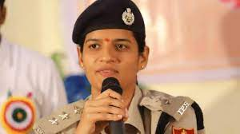

*Ms Amrita Duhan, a doctor turned IPS officer, is a brilliant example of how a woman can achieve even the most difficult goals in life if she does not let her hopes and aspirations die. Ambitions and ambitious desires have no age restrictions.*

*Ms Amrita Duhan, a 2006 batch officer, has demonstrated this throughout her life. She is a licenced physician as well as a police officer. Despite having a stable work and life, she continued to wish for more. Her passion helped her to pass the UPSC and join the Indian Police Service (IPS).*

*Ms. Duhan, who is currently the DCP Crime Commissionerate in Jaipur, is an example to every woman who has lost her sense of self while coping with the countless responsibilities of daily life. Ms. Duhan explained her ideas during a Ted Talk. "We are not born with genetic greatness," she explained. Some of us will have to put in a lot of effort to reach our goals. We are ordinary people who, through our hard work and perseverance, have pushed us to set remarkable goals for ourselves."*

*Ms. Duhan came from a poor household in Rohtak, Haryana, and, like other women, she desired a profession and a family. So she got her MBBS and then went on to get her MD (Pathology). After that, she got a job of Assistant professor in a government college.*

*She was content with her occupation since, to her, what could be more honourable than being a doctor? She married, had a child, and became a stay-at-home mom all at the same time. She was content in her role as a working mother.*

*Ms. Duhan's younger brother was picked for IPS when she was juggling her family and profession. She was much inspired by her brother. So, she began studying for the examinations during the week and devoted her weekends to her family. This was a difficult period for her because her son was growing up and required her the most of the time. She handled everything while concentrating on the preparation. Her dedication paid off in 2016, when she was picked for IPS. Ms Duhan was 33 years old and had little physical activity when she began her training at the National Police Academy. She had a pelvic fracture. This did not deter her, and she continued to push herself, completing each training session. She was ultimately chosen as the second-best probationer in the entire group!*

***Solutions :-***

*“Don't let your dreams die”*

*Amrita Duhan had experienced a challenging life in her early days. She belonged to a poor family but her aspirations were beyond these limits. From a doctor to an associate medical professor to becoming the best all rounder lady IPS probationer. She is an epitome of inspiration for the youth. Despite having a small child, she did not let her dreams die. She has done it all while managing her personal and professional lives both and chased her dream to crack UPSC with flying colors. A big credit behind her achievements goes to her in-laws and her husband, their countless support to Amrita inspired her and motivated her to face every challenge with great confidence and with full dedication. She had this dream since her childhood days when she used to see the daily soap "Udaan" broadcasted on the Indian television which depict a girl having the same dream as of Amrita. She was much inspired from that character. She said that "We are not born with genetic greatness". All of us are mere ordinary person but an ordinary person can do such extraordinary things, all that we need is hard work and perseverance. Her continuing dedication finally paids off. Success is the good fortune that comes from aspiration, desperation, perspiration and inspiration. Having aspirations is nice but fulfilling them is exhilarating.*

1. ***LEILA SETH***

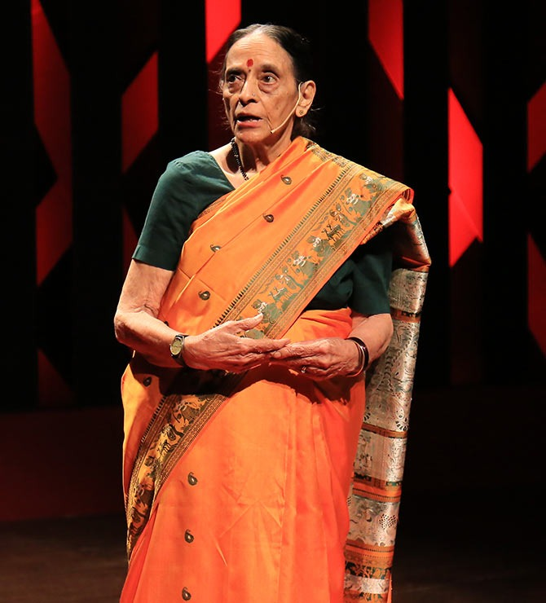

*Leila Seth famously known as Justice Seth was born on 20 October 1930 at Lucknow, Uttar Pradesh. A few weeks after her 12th birthday her father just passed away. Now it was very difficult for her mother to upbring her with her 3 brothers, but her mother never discriminated her. She somehow managed to pay their school fee with help of some scholarships and friends.* ***Leila did not originate from a wealthy household, but she never allowed that stop her from succeeding****. She got married at 20 with Prem Seth. They moved to London where she studied law and topped the bar exams. She also became IAS in 1959. When she came to India, she needed to be trained under a senior lawyer so the she can practice in India, she found one of the famous lawyers of the time Sachin Chaudry after many difficulties. Sachin resisted not have a lady in the department but after many arguments by Seth he had no question left. After 20 years of practice, she became the first Woman Judge in Delhi HC. Her men colleagues used to address her as ‘Lady Judge’, to which she always answered ‘do you call a men judge ‘gentlemen judge’? ‘, a judge is a judge’. She was the part of the 15th law commission from 1997 to 2000, where she contributed in the amendments in the Hindu Succession Act 1956. She was also a member of the JS Verma Commission that was established to overhaul India's rape laws in the aftermath of the infamous 2012 Delhi gang-rape case.*

*Justice Leila Seth died after suffering a cardio-respiratory attack on the night of 5 May 2017 at her residence in Noida, aged 86 leaving behind a weighty legacy.*

*In the TED talk she appeals as a daughter to her parents “Oh Father, give me a chance, just give a chance. Oh Mother, break the bonds of tradition and let me into the sunlight to dance, to dance, to dance”.*

***Solutions******:-***

*Leila Seth is a woman who was brought with her three brothers alone by her mother, right from the beginning she had lack of resources but even then, she managed to be a Woman Ahead of her Time.*

*Her simple and calm nature to deal with any problem makes her extraordinary. In an interview she reveals, with a smile on her face that during her three and a half year stay in London when she was preparing for the bar exams, she just had 8 sarees with her.*

*Justice Seth was never bogged down by her male colleagues, She held her own refusing to do just women's cases. Instead, she chose to compete with them taking up tax matters, constitutional law and criminal cases.*

*What made her a woman ahead of the time was her firmness and patience that was shown when she answers every question of Sachin Chaudhary, instead of being quiet. Her firmness and determination made her enter the Indian law.*

*She was also a good decision maker as she was a member of JS Verma Commission and also the 15th law commission for 3 years where she contributed in the amendment of Hindu Succession Act, 1956, to ensure that all the daughters get their equal legitimate share from not only from their parents’ property but also from their ancestral property.*

*Justice Seth is revered as a strong supporter of the gay rights movement. Her disapproval of Section 377 is known to the world as is her belief that "gay child needs more love." This shows that she has a diverging mindset.*

1. ***POOJA CHOPRA***

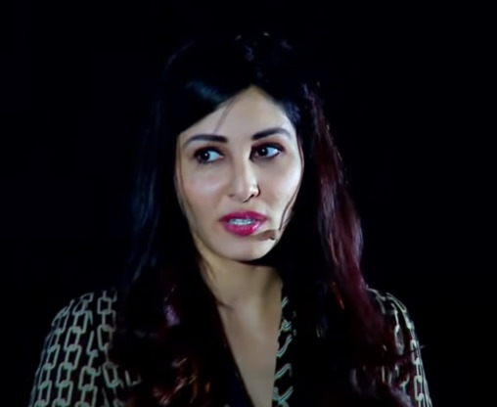

*Pooja Chopra is the first Indian to win the title of “Beauty with a purpose” for India. She was abandoned by her father at birth since after Pooja’s sister he did not want a second girl child. When her mother, Neera Chopra was asked to make a choice between her daughter and her husband, she chose her 20 days old daughter, left her marital house and moved to Mumbai with an infant in one hand and a daughter of 7 years old in another. According to her TED talk her mother exclaimed:*

*‘One day this girl will make me proud’.*

*Pooja calls her mother a fighter. Neera had to put a stone on her heart to leave a month-old child and a seven-year-old daughter all by themselves alone in the house as she had to go out to earn a living. Both the sisters had also shown their full support to their mother. Being intelligent Pooja did not ask her mother for a cycle when all the children of her age already had it as she knew that making such a demand would make her mother work even during nights. Both of them never complained for reusing notebooks, bags and shoes. She was such a brilliant child in studies that her teachers thought she would grow up to be a doctor or an engineer. But destiny had something else for her. When Tanushree Dutta won the Miss India struck her and she realized that this is something she wants to do. She wanted to participate in the Miss India Pageant. Though her friends laughed at her idea of being Miss India she did not lose her hope. Miss India was like blood in her veins. She was attending her college and participating in beauty contests side by side. Pooja was very much determined in achieving her goal. She packed her bags and left for Bombay where the Miss India crown was waiting for her. Her dinner used to be the two chapattis and black boiled chana which was given as prasad in the Sai Baba Temple near her PG. This was one of her ways of saving money as she knew that she would need it in the whole process. In spite of all these difficulties, she didn’t even try to share her feelings with her mother. As it is very well said that hard work pays off, Pooja Chopra finally won Miss India and the crown was on her head. Calcutta was the same place where her mother was asked to leave her and where she had won and achieved her goal. She was given the title of “Beauty with a purpose” and hence became a successful woman.*

***Solutions :-***

*Crowns are not made of rhinestones, they are made of discipline, determination Consistency and courage. Pooja Chopra, the Miss World was abandoned by her father at birth and she was brought up by her mother all alone. This girl had never complained to her mother for anything and had tried to adapt whatever the situation and however painful it was. According to her one should never wait for someone to come and fix things for them. Though her friends laughed at her idea of being Miss World, this girl did not give up and continued to do her work. This was due to the believe that she had on herself. Pooja sprained her ankle while running down a flight of stairs a week before the Miss World grand finale, and was advised to stay in bed for three weeks. Despite having a broken ankle and wearing a cast, the stunning beauty continued to compete in the competition and even performed during the talent round. This shows how determined she was to achieve her goal. She was praised by everyone for her boldness and fortitude. She won the BWAP Award for her charitable work for ‘Project Nanhi Kali’ which aims to educate underprivileged girls in India. She had an ambition of achieving something and this fired the flames of her soul. Her hard work and determination made her the first Indian to win the title of 'Beauty with a Purpose' (BWAP) at the Miss World competition. Thus, it can be concluded from Pooja’s experience that if have courage and determination to do something then no one can stop us from accomplishing our dreams.*

1. ***SURABHI GAUTAM***

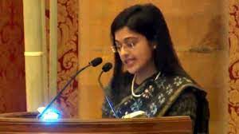

*“Growing up as a Meritorious student”*

*The speaker Surabhi Gautam here in her TEDx talk, as an RGPV Alumni talks about her package of success from being born in an orthodox village of Madhya Pradesh and twenty- five years later walking into the same village with the entire village celebrating her success by welcoming her with garlands and chanting ‘Gaon ki beti kesi ho, Surabhi Gautam jesi ho’.*

*This talk reveals about her rejections, failures, determination and willpower that owed her those successes. A studious student, Surabhi remembers her mathematics paper in class 5 and says, “I had scored full marks in that paper and the recognition and appreciation that came my way after that pushed me to study harder.” But her heart which always wanted to diversify made her try her hand at painting, sketching, drawing and embroidery. Her busy schedule didn’t let her notice the creepy pain in her body which made her bedridden after some days. The doctors of Jabalpur diagnosed her with Rheumatic fever for which she needed to be injected with antibiotic penicillin every 15 days. In ensuring that she does well, Surabhi scored 100 marks in mathematics and science during her class 10 board examinations. This also ensured that she found a spot in the State merit list, making her a “pseudo-celebrity”, as she describes herself. In a course of interviews, a word flashed in her mind out of nowhere and she said that she wanted to be a collector. Next day the news came: “Collector banna chahti h Surabhi.” Then she passed 12th and got APJ Abdul Kalam Scholarship for securing maximum marks in science stream.*

***She takes up a challenge***

*With so many dreams and aspirations, she moved to Bhopal to pursue Engineering. Surabhi was the first girl from her village who was studying in a college outside the village. So she had to perform well anyhow. Having studied in a Hindi medium school, entering college where everyone conversed in fluent English was a big shock for Surabhi. She recollects her first day when she was asked to introduce herself and then explain a particular physics term. While she knew what it meant, the inability to communicate in English had her standing there looking blank. Surabhi who was completely shattered was then encouraged to take up the challenge and reminded that if she was to return, that would close the door for all the other girls in her village. From that point, there was no stopping Surabhi. She worked doubly hard and managed not just to learn English, but to converse fluently in the language. She went on to top not just her college, but also the University and was awarded the Chancellor’s Scholarship.*

*If this is not inspiration, I wonder what is.*

***Her foray into civil services***

*Surabhi appeared for several exams: GATE, ISRO, SAIL, MPPSC, BARC and she qualified all of them. She cleared the interview of Bhabha Atomic Research Centre from where she got the first offer letter and became a scientist.*

*She cleared the Engineering services (IES) exam with AIR 1. She was the first lady in India to top Engineering Services Exam and her marks were the maximum in history of UPSC till date. She resigned from BARC and joined railways. But she was not happy. It was her mother who reminded her of her interview which made her decide to prepare for Civil Services Examination. She was doing her railway job and got just 3-4 hours to prepare for her exams. And finally, she got AIR 50 in coveted exam- CIVIL SERVICES EXAMINATION 2016.*

***Solutions* :-**

*Success is not final; Failure is not fatal. It is the courage to count that continues.*

*The speaker here, Surabhi Gautam, came from an orthodox village which was the very first obstruction in her education and dreams. To wade smoothly through such a challenge, one has to show undaunted determination and never give up spirit.*

*Coming from a small village, lack of timely information and inadequate global exposure constituted one of the biggest problems she ever faced. Quality of education and financial restraint were other hurdles that came in the way of her dreams. But believing that problems are just a norm throughout our lives and sometimes they become helpful because they push people to work hard. Trying to be flexible, adaptable and efficient in every situation that comes our way can be a fruitful solution. Boosting your skill set and competence along with believing that you are bound to do good things, ensure that big things come into your life. Resilience and ability to cope up with problems can help to overcome setbacks and treat them as opportunities. Proper time and workload management ensured that Surabhi manages her railway job and Civil Services exam preparation simultaneously.*

*Not only hard work but smart work provides golden results. Good relationships can make all challenges easier like Surabhi had with her parents. No doubt, unflinching guidance and support from parents are icing on the cake. Playing the long game is a trait that one needs to master as winning requires patience and persistence and moreover, there is nothing like overnight success. The speaker’s inferiority complex became an opportunity for her to learn English.*

*Thus, there is no limit to what a woman can accomplish.*

1. ***MADHAVI SHANKAR***

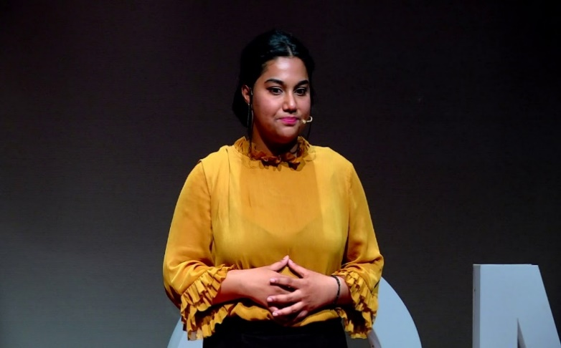

***Introduction :***

*In this talk, the speaker aims to throw light on the current situation of education in women in India. She shares some disturbing facts about gender bias in India and each one of our significant roles in it. Madhavi Shankar is the Co-Founder and CEO of Space Basic Inc, a networking app that facilitates seamless information sharing within members of Universities, Hostel Management and Global Partners seeking student engagement.*

*Also being a 2012 CMRIT graduate in Computer science Engineering, Madhavi is passionate about building and engineering consumer-driven products across scale.*

*She has also contributed highly towards global women employment and equal opportunities and has been recognised as one of the 'Top 60 Women Transforming India' by The Government of India as well as the United Nation. This talk was given at a TEDx event using the TED conference format but independently organized by a local community.*

***Story of a 7th Grader :***

*She starts with a story about a young girl Nandini who was in the 7th grade at that time when the speaker met her. Nandini used to go to a government school and came back to home just after the school finished to complete some work according to her parents.*

*When the speaker looked into what work Nandini used to do, she was so surprised to see that Nandini was helping a 10th grader finish his homework when she herself was in the 7th grade. Seeing so much talent in Nandini speakers mother started funding her studies and tuition.*

*Few years later, when Madhavi Shankar was preparing to leave to Australia to finish her studies, she got to know that Nandini was being married. She was perplexed by this decision made by Nandini and her parents.*

***Problem :***

*Nandini’s Parents convinced her that marriage is the only solution to her problems and reason for her existence when she was in her low and had no self confidence that she would be able to pass college for further studies.*

***(Lack of Self Confidence)***

*Major contributor to lack of Self Confidence -> Lack of access to real world skills and role models.*

*In 2016, Madhavi Shankar returned from Australia and started a company Space Basic Inc. focused on optimising communication and collaboration within university students. After some months of this she again met Nandini and found that she was married with two children working at a clothing store at 19.*

*Can you believe, the girl who used to solve maths questions of 10th grade when she was only in 7th grade working in a clothing shop.*

*Campus Recruitment of Madhavi Shankar*

*In 2012 Madhavi Shankar was attending campus recruitment and was thinking to herself what she was going to do with her life. Neither she had good grades to be recruited by the company, nor did she have the skills they were looking for but her male co – members or students laughed it off knowing that they will figure it out.*

*Difference in her and her male co members attitude and confidence*

*Thought of a woman on the Self – Confidence of boys -> The thought that came to her mind was that Are the boys born with it or they are brought up with it?*

***Initiative :***

*Govt. Of India is initiating workshops for women to train them and make them job ready but personally Madhavi Shankar thinks that there should be initiative to impart Self – Confidence in the moral of girls and women.*

*She noticed that the main reason for her stable and successful career now is due to fact she was introduced to open and real-world opportunities which helped her identify her skills and strengths.*

*This is a problem only our generation can solve. How will we contribute to growth when we cannot achieve or create equal opportunities? Gender inequality is not only pressing moral and social issue but it is critical to economic challenge.*

*Fact -> Over 2.7 billion women are legally restricted from having the same jobs as men.*

*Effect -> Globally countries are losing over a 160 trillion dollars in wealth because of the difference in earnings of men and women.*

***Success With Alarm***

*The speaker is happy to know that these days more and more girls as well as women are enrolling in studies, college, schools and are more successful than boys. For over 7 years the trends have been the girls are more successful than boys in clearing the 10th exams.*

*What’s alarming after all this is the fact that more than 84% of these girls or women who enter in schools, colleges are not graduating i.e. Ratio of girls enrolling/To those who are actually graduating in jobs is very less.*

*In India, more than 250 million more Indian women could be employed but are not.*

***Indian Touch on Womanhood and Feminism***

*Strong traditional influences embarked on from a young age (concept of prejudice relatively rigid structure imposed on us that is women come with the blueprint of being caretakers and men considered to be decision makers or providers)*

*Preconceived notion that is with women are brought up with education is stepping stone to a good husband.*

*Parent collect all their life together so as to make their daughter married without thinking that what she needs. Instead, they could have saved all this money to invest in her dreams and goals.*

***Definition of Me***

*When today someone asks her who she is she says, “I am an entrepreneur, a word with no mention of any gender or caste or anything describing just that she is someone who likes creating goals, achieving targets and working every morning with a goal to have an impact on the society and the world.*

*The only times she is reminded of being a woman is whenever she is in a family function or a social gathering asked to why she is 29 and still unmarried (without asking about her company, or what she likes to do or doing or is she working or not).*

*How are we going to make a change in the society or expect it when we are not able to do anything about these social questions in our own family.*

***Solution :-***

*“Gandhi said educate a man and you educate a person; educate a woman and you educate a family. Education is the fundamental towards upliftment “*

*When the speaker saw through her life, she found that the main reason for her success was her interaction to the real-world resources which made her so capable to become what she is now.*

*According to her the first step to empowerment is enrichment of Self Confidence and Belief in women and girls of today’s world so that they know that nothing is impossible and everything is achievable if we believe in ourselves.*

*Parents collect whole their lives with money to marry off their daughter feeling this as their life’s objective without thinking that what their daughter actually want. If parents invest this money and time in their daughters dream and happiness, I believe that will be happiest moments of their life.*

*At last, the change that we want to see in the world can only be brought if opportunities of equal weightage will be created for all, not based on any gender inequality creating a level of equal importance for everyone.*

*The speaker herself has a start-up which’s goal is only to empower students regardless across cities or villages. They want to provide them with equal opportunities because they believe students are the future of our country.*

*“There is no greater pillar of stability than a Strong, Free and Educated woman”.*

***Correlation with life skill***

*One of the most important life skills that can be implemented in this topic is Resilience. Using resilience’s skill of* ***adapting to hardships and setbacks*** *in life is significant step for dealing with judgments of society with people who are sex workers. To build* ***competence****, individuals develop a set of skills to help them trust their judgments and make responsible choices. There should be* ***educational approach*** *considering prostitution as an equivalent profession instead of discriminating against it and making assumptions.*

***Tolerance*** *is not just agreeing with one another or remaining indifferent in the face of injustice, but rather showing respect for the essential humanity in every person. In the end we must not forget that we all are humans, irrespective of our profession, race, colour etc. Any kind of intolerance related to work will only generate resentments, prejudices and fears that lead to an important division between people, which makes it impossible to live in* ***harmony****, based on respect and recognition of the other.*

*When people learn to* ***cope with stress effectively****, they are better prepared to handle adversity and setbacks. Developing an understanding of* ***internal control*** *helps individuals act as problem-solvers instead of victims of circumstance*

***Conclusion***

*The greater the obstacle, more the glory in overcoming it. But staying committed and firm belief on oneself can break down the problems and one can easily conquer any obstacle that comes her way.*

*All of us are mere ordinary person but an ordinary person can do such extraordinary things, all that we need is hard work and perseverance.*

*Power to achieve anything lies in mind and will power. Difficulties test the courage, patience, perseverance, and true character of a human being. Adversity and hardships make a person strong and ready to face the challenges of life with equanimity. It is only when one toils and sweats it out that success is nourished and sustained.*

*We have studied 5 TED talks of those women who have successfully achieved their goals by overcoming all the hurdles in their path setting an example for the upcoming generations and teaching us about determination, firmness, self-belief, consistency and hard work, no matter who you are, where you come from and how do you look, what only matters is what you do.*

***CONTRIBUTION OF EACH MEMBER***

***(Refernces of vedio link) :-***

***1) Himanshu Dixit (21103262) : (PDF CREATOR)***

***TED TALK BY MADHAVI SHANKAR -*** [***https://youtu.be/gupM7RMANZc***](https://youtu.be/gupM7RMANZc)

***2) Aashutosh Pradhan (21103242) :***

***TED TALK BY LIELA SETH -*** [***https://youtu.be/dpC2jGqu4G0***](https://youtu.be/dpC2jGqu4G0)

***TED TALK BY SURBHI GAUTAM -*** [***https://youtu.be/sKvMxZ284AA***](https://youtu.be/sKvMxZ284AA)

***3) Aryaman Vishnoi (21103260) :***

***TED TALK BY AMRITA DUHAN -*** [***https://www.youtube.com/watch?v=FR24hPsY4QE***](https://www.youtube.com/watch?v=FR24hPsY4QE)

***4) Aryan Razdan (21103271) :***

***TED TALK BY POOJA CHOPRA -*** [***https://youtu.be/CUeIqKulW6k***](https://youtu.be/CUeIqKulW6k)

